Project

Report

for

Android Chat APP

Version 1.0 approved

Prepared by:

1. Bilal Ahmed Khan (k200183)
2. Muaaz Alam (k200212)

7th May 2023

Table of Contents

Table of Contents

1. Introduction 1

1.1 Purpose 1

1.2 Document Conventions 1

1.3 Intended Audience 1

1.4 Product Scope 1

1.5 References 11

2. Overall Description 2

2.1 Product Perspective 2

2.2 Product Functions 2

2.2.1 Group chat: 2

2.2.2 Private messaging: 2

2.2.3 Multimedia sharing: 3

2.2.4 User authentication: 3

2.2.5 User profile: 3

2.2.6 Real-time messaging: 3

2.3 User Classes and Characteristics 3

2.3.1 Individual users: 3

2.3.2 Community users: 3

2.3.3 Professional users: 3

2.3.4 Students: 4

2.3.5 Characteristics 4

2.4 Operating Environment 4

2.5 Design and Implementation Constraints 4

2.6 Assumptions and Dependencies 5

3. External Interface Requirements 6

3.1 User Interfaces 6

3.2 Hardware Interfaces 10

3.3 Communications Interfaces 10

4. Other Nonfunctional Requirements 10

4.1 Performance Requirements 10

4.2 Safety Requirements 10

4.3 Compatibility 10

4.4 Usability: 10

5. Other Requirements 11

Revision History

|  |  |  |  |
| --- | --- | --- | --- |
| **Name** | **Date** | **Reason For Changes** | **Version** |
| Chat App | 7th May 23 | None | 1.0.0 |
|  |  |  |  |

# Introduction

## Purpose

The purpose of this Flutter chat app project is to provide a platform for users to communicate with each other in both group and private settings. The app will allow users to create and join groups, where they can chat with multiple people at once. Users will also be able to have private conversations with individuals, allowing for more intimate and focused communication.

The app's group chat feature will be particularly useful for communities or organizations that need a dedicated space to discuss specific topics or collaborate on projects. Users can create groups for different purposes, such as work teams, hobby groups, or study groups, and invite members to join.

In addition to group chats, the app will also enable private messaging between users. This feature will be useful for one-on-one conversations, such as catching up with friends or discussing confidential matters. Users can send text messages, images, videos, and other multimedia content in private messages.

Overall, this Flutter chat app project aims to provide a convenient and user-friendly platform for users to communicate with each other, whether they need to chat in groups or privately. With features such as group and private messaging, users can stay connected with their communities and communicate effectively with individuals, all in one app.

## Document Conventions

None

## Intended Audience

The intended audience for this Flutter chat app project will be individuals who value communication and connection with others. This app will appeal to a broad range of age groups and demographics, including young adults, professionals, and seniors. However, the target demographic for this app is primarily people who are digitally savvy and comfortable using mobile applications.

The app's group chat feature will be particularly attractive to young adults who are interested in connecting with like-minded individuals for social or hobby-related activities. They can create or join groups for their interests, such as sports teams, book clubs, or gaming groups. This app will also appeal to professionals who need to collaborate with their colleagues on specific projects, allowing for real-time communication and efficient teamwork.

The private messaging feature will appeal to users who value privacy and security in their communication. The app will be useful for anyone who wants to connect with friends and family members one-on-one, as well as professionals who need to discuss confidential matters. Overall, the target demographic for this chat app project will be individuals who value communication, connection, and convenience in their daily lives.

## Product Scope

The scope of this Flutter chat app project will include the development of a mobile application that allows users to communicate with each other in group and private settings. The app will have features such as group chat, private messaging, multimedia sharing, and notifications.

The app will be available for both Android and iOS devices and will be designed to be user-friendly and easy to navigate. It will be developed with the latest technologies to ensure that it is fast, reliable, and secure. The app will also have a sleek and modern design that is visually appealing to users.

In terms of functionality, the app will allow users to create and join groups for different purposes, such as work teams, hobby groups, or study groups. Users will be able to send text messages, images, videos, and other multimedia content in private messages. The app will also feature push notifications, ensuring that users never miss an important message or update.

To ensure that the app is successful, it will need to be thoroughly tested and debugged before release. The development team will also need to implement a user feedback system to gather input and improve the app based on user needs and preferences. Overall, the scope of this chat app project will be to develop a robust and user-friendly platform for communication and connection between individuals.

# Overall Description

## Product Perspective

The product perspective of this Flutter chat app project is that it provides a platform for users to communicate and connect with each other in both group and private settings. From the user's perspective, the app provides a convenient and user-friendly interface for chatting and sharing multimedia content with friends, family, colleagues, and communities.

From a business perspective, the app can be viewed as a tool for fostering communication and collaboration within teams or communities. The app's group chat feature can be particularly useful for organizations that need a dedicated space to discuss specific topics or collaborate on projects. The private messaging feature can also be useful for professionals who need to discuss confidential matters with colleagues or clients.

The product perspective of the app is also influenced by the broader mobile app market, which is growing rapidly and becoming increasingly competitive. To remain competitive and attract users, the app will need to offer a range of features and services that are user-friendly, secure, and reliable. It will also need to be updated regularly to keep up with the latest trends and technologies in mobile app development.

## Product Functions

## The Flutter chat app project will have several product functions that will enable users to communicate and connect with others. These functions include:

### Group chat:

## Users will be able to create and join groups for specific topics or interests, allowing them to communicate and collaborate with like-minded individuals.

### Private messaging:

## Users will be able to send private messages to individuals or small groups, allowing for more personal and confidential conversations.

### Multimedia sharing:

## Users will be able to share images, videos, and other multimedia content with others in both group and private settings.

### User authentication:

## Users will be required to sign in or create an account to use the app, ensuring that only authorized users can access the app's features.

### User profile:

## Users will be able to create and customize their profiles, including their name, profile picture, and bio, making it easier for others to find and connect with them.

### Real-time messaging:

## The app will feature real-time messaging, ensuring that messages are delivered instantly and that users can have fluid and seamless conversations.

## Overall, these product functions will enable users to communicate and connect with others in a convenient, user-friendly, and secure manner.

## User Classes and Characteristics

## The user classes and characteristics of the target audience for this Flutter chat app project can be broken down into the following categories:

### Individual users:

## These are users who want to communicate with friends and family in a private setting. They may use the app to share personal updates, photos, and messages with their loved ones.

### Community users:

## These are users who want to communicate with a group of people who share similar interests or goals. They may use the app to join or create groups related to specific topics or activities, such as fitness, gaming, or book clubs.

### Professional users:

## These are users who want to communicate with colleagues or clients in a private and secure setting. They may use the app to discuss work-related topics, share files, and collaborate on projects.

### Students:

## These are users who want to communicate with classmates or study groups. They may use the app to discuss classwork, share notes and resources, and collaborate on projects.

### Characteristics

## of the target audience for this app may include individuals of various ages, professions, and backgrounds. The app's user interface and features will need to be designed to cater to a broad range of users, including those who may not be familiar with technology or mobile apps. The app will need to be user-friendly, visually appealing, and easy to navigate. Security and privacy will also be important features for the app, especially for professional and confidential conversations. Additionally, the app will need to be scalable to accommodate a growing user base and expanding features.

## Operating Environment

The app has been developed used the Flutter framework that uses dart language.

It can on both:

1. Andriod
2. iOS

platforms natively.

## Design and Implementation Constraints

The design and data implementation constraints for this Flutter chat app project include the following:

1. **User Interface (UI):**

The app's user interface needs to be intuitive, user-friendly, and visually appealing. The design must take into account the different screen sizes and resolutions of mobile devices. It must be responsive and adaptable to different devices and orientations.

1. **Data Storage:**

The app must be able to store user data securely and efficiently. The app will need to implement a reliable and scalable database system that can handle a large number of users and messages.

1. **Network Connection:**

The app must be able to work effectively on a variety of network conditions, including 2G, 3G, and 4G networks. It must also support offline mode, allowing users to read and send messages when they are not connected to the internet.

1. **Security**:

The app must implement strong security measures to protect user data and prevent unauthorized access. This includes encrypting sensitive data, implementing secure authentication methods, and implementing security measures to protect against data breaches and hacking.

1. **Performance:**

The app must perform efficiently and smoothly, even when handling large volumes of data and messages. The app must be optimized for fast loading times and low latency to ensure a seamless user experience.

1. **Compatibility:**

The app must be compatible with a wide range of devices, operating systems, and web browsers. It must be tested thoroughly on different devices and platforms to ensure optimal performance and compatibility.

In summary, these design and data implementation constraints will need to be taken into consideration when developing the Flutter chat app project. By addressing these constraints, the app can be developed to provide a secure, reliable, and user-friendly platform for communication and connection.

## Assumptions and Dependencies

**Assumptions:**

Some assumptions that may have been made about the users of this Flutter chat app project during its development are:

1. Users are comfortable with mobile devices and using chat applications.
2. Users are interested in communicating with others in both private and group settings.
3. Users value security and privacy in their online communications.
4. Users appreciate an intuitive and visually appealing user interface.
5. Users are looking for a chat app that is reliable, efficient, and user-friendly.
6. Users may have different preferences when it comes to features, such as multimedia sharing and push notifications.
7. Users may want to connect with others based on shared interests or geographic location.
8. Users may want to customize their profiles and preferences to reflect their personalities and interests.

It's important to note that these assumptions are not necessarily true for all users and that it's essential to gather feedback from real users and adjust the app's features and design based on their needs and preferences.

**Dependencies:**

The Flutter chat app has the following dependencies:

dependencies:

  flutter:

    sdk: flutter

  cupertino_icons: ^0.1.2

  cloud_firestore: ^0.13.5

  firebase_auth: ^0.16.0

  image_picker: ^0.6.5+3

  firebase_storage: ^3.1.5

dev_dependencies:

  flutter_test:

    sdk: flutter

# External Interface Requirements

## User Interfaces

* 1. Log In Screen:

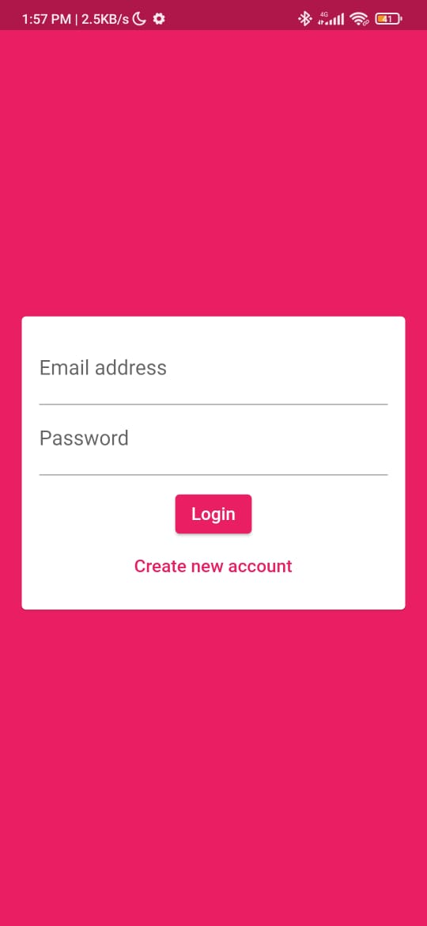

* 1. 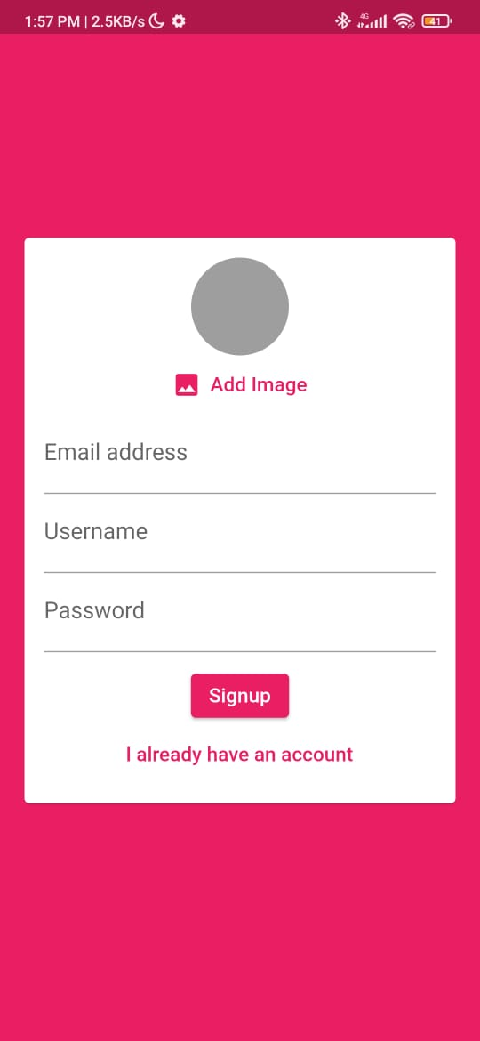Signup Screen:

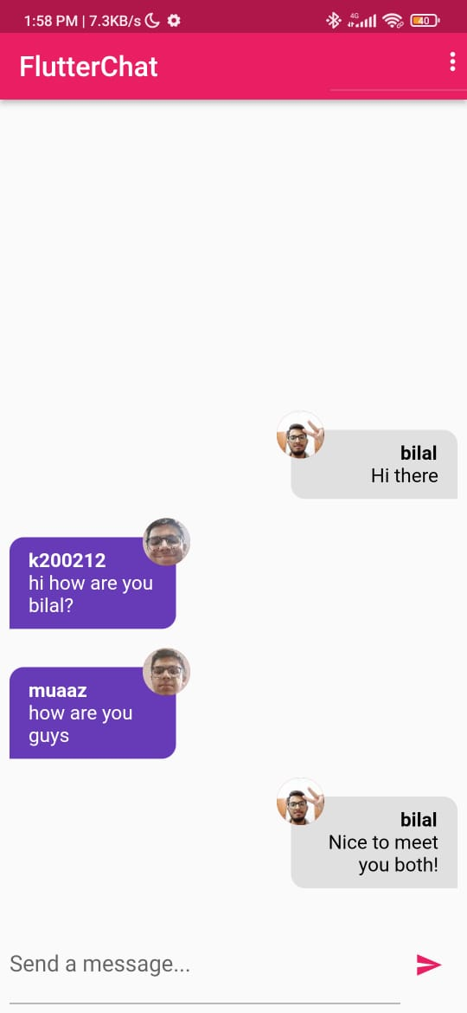Chat Screen:

## Hardware Interfaces

The app runs natively on both Android and iOS

## Communications Interfaces

The Flutter chat app may use several communication interfaces to enable users to interact with the app, including:

* **Graphical User Interface (GUI) -** The app's graphical user interface provides an intuitive and user-friendly way for users to navigate the app and access its various features.
* **Touchscreen Interface** - As a mobile app, the Flutter chat app uses a touchscreen interface to enable users to interact with the app by tapping, swiping, and scrolling on their device's screen.
* **Keyboard Interface** - The keyboard interface allows users to type messages and input text in the app's various forms and fields.
* **Audio/Video Interface** - The app may support audio and video communication, allowing users to make voice and video calls within the app.
* **Network Interface** - The app uses network interfaces to connect to the internet and communicate with other users' devices through servers.
* **Push Notification Interface** - The app may use push notifications to alert users to new messages or updates, even when the app is not currently active on their device.

Overall, these communication interfaces work together to provide a seamless and engaging user experience, making it easy for users to connect and communicate with others through the Flutter chat app.

# Other Nonfunctional Requirements

## Performance Requirements

The app should be responsive and fast, with quick load times and smooth scrolling, even when working with large chat groups or multimedia files.

## Safety Requirements

The app must have robust security measures in place to protect user data and privacy, including secure data transmission, password protection, and encryption.

## Compatibility

The app should be compatible with a variety of mobile devices and operating systems, including iOS and Android.

## Usability:

The app should be user-friendly, with an intuitive interface, clear navigation, and straightforward instructions.

# Other Requirements

None

# References

The reference sources used in developing this Flutter chat app project were the official documentation from Flutter and Firebase. Flutter is an open-source mobile application development framework that is used to develop high-performance apps for Android and iOS platforms. The official Flutter documentation provides a comprehensive guide to developing mobile applications using Flutter, including tutorials, code samples, and best practices.

Firebase is a cloud-based platform that provides developers with a variety of tools and services for building mobile and web applications.

Firebase: [Firebase Documentation (google.com)](https://firebase.google.com/docs)

Flutter: [Flutter - Build apps for any screen](https://flutter.dev/?gclid=Cj0KCQjwu-KiBhCsARIsAPztUF00QZ0AZTaez6A4_0q83UqA7u5_cCpIMjNzjBb4X1p2lQrMKrQKKV8aAmL7EALw_wcB&gclsrc=aw.ds)